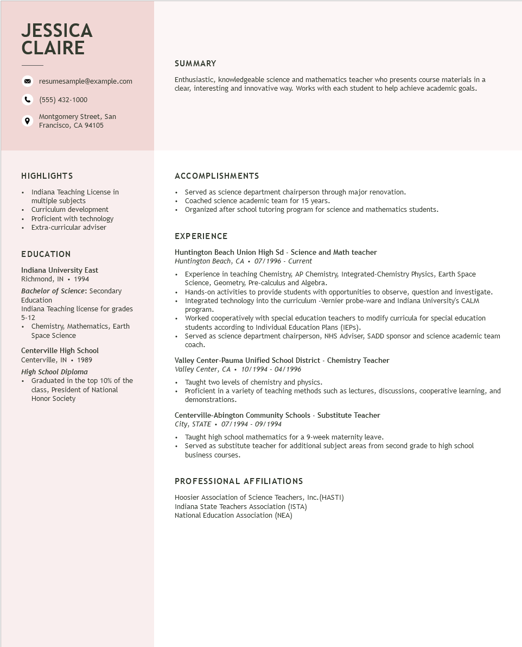
JESSICA CLAIRE
resumesample@example.com
(555) 432-1000
Montgomery Street, San Francisco, CA 94105
SUMMARY
Enthusiastic, knowledgeable science and mathematics teacher who presents course materials in a clear, interesting and innovative way. Works with each student to help achieve academic goals.
HIGHLIGHTS
•
Indiana Teaching License in multiple subjects
• Curriculum development • Proficient with technology
• Extra-curricular adviser
EDUCATION
Indiana University East
Richmond, IN 1994
Bachelor of Science: Secondary Education
Indiana Teaching license for grades 5-12
• Chemistry, Mathematics, Earth
Space Science
Centerville High School
Centerville, IN 1989
High School Diploma
• Graduated in the top 10% of the
class, President of National Honor Society
ACCOMPLISHMENTS
Served as science department chairperson through major renovation.
• Coached science academic team for 15 years.
• Organized after school tutoring program for science and mathematics students.
EXPERIENCE
Huntington Beach Union High Sd - Science and Math teacher
Huntington Beach, CA 07/1996 - Current
Experience in teaching Chemistry, AP Chemistry, Integrated-Chemistry Physics, Earth Space Science, Geometry, Pre-calculus and Algebra.
• Hands-on activities to provide students with opportunities to observe, question and investigate. Integrated technology into the curriculum -Vernier probe-ware and Indiana University's CALM program.
Worked cooperatively with special education teachers to modify curricula for special education students according to Individual Education Plans (IEPs).
• Served as science department chairperson, NHS Adviser, SADD sponsor and science academic team coach.
Valley Center-Pauma Unified School District - Chemistry Teacher
Valley Center, CA⚫ 10/1994 - 04/1996
• Taught two levels of chemistry and physics.
• Proficient in a variety of teaching methods such as lectures, discussions, cooperative learning, and demonstrations.
Centerville-Abington Community Schools - Substitute Teacher
City, STATE⚫ 07/1994 - 09/1994
• Taught high school mathematics for a 9-week maternity leave.
• Served as substitute teacher for additional subject areas from second grade to high school business courses.
PROFESSIONAL AFFILIATIONS
Hoosier Association of Science Teachers, Inc. (HASTI)
Indiana State Teachers Association (ISTA)
National Education Association (NEA)

